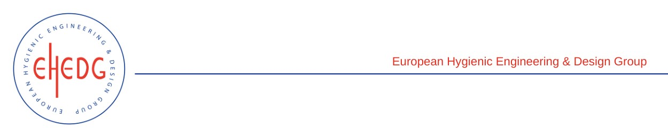

EHEDG Advanced Course on Hygienic Design

24-27 January 2023
Amsterdam, Netherlands

Authorised trainer: Wouter Burggraaf

Certified Attendees
Hemant Ghule
René Heinz
Janella Hidalgo
Harshad Joshi
Preben Mørner-Bartnes
Elina Nousiainen

