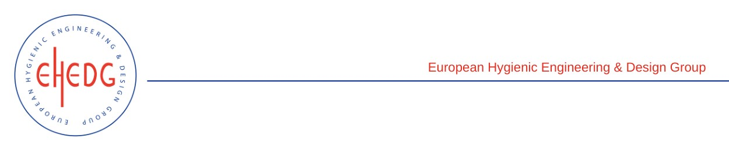

EHEDG Advanced Course on Hygienic Design

8 to 10 November 2022
FIRDI, Taiwan
Authorised trainers: Shih-Rong Huang & Yu-Ming Chen

Certified Attendees
Shao-wen Wei
Chi-Lin Chao
Cheng-Chi Hsieh
Cheng-Kang Lang
Pi Fan Liu
Yu-Shu Lu
Tzu-Yen Kao
Chao-Chi Huang
Chao-Ming Kang
Jian-Cheng Qiu
Pei-Ching Chiang
Zih-Sian Yang

