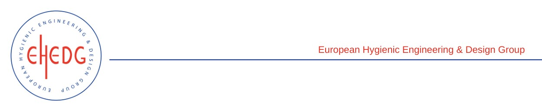

EHEDG Advanced Course on Hygienic Design

2-9-19 October 2018
Melle (Belgium)

Authorised trainer: Hein Timmerman

Certified Attendees
Bart Clerx
Bastian De Vos
Dieter Venneman
Frederik Verschave
Jonathan Vandoorne
Kris Mahieu
Mathijs Gryson
Mathijs Laporte
Robbrecht Seynaeve
Rodrigo Cruz
Rony Boeykens
Ruben Vermeersch
Steff Luyten
Thomas Vandenbrance
Tom De Munster
Yannick Arys

