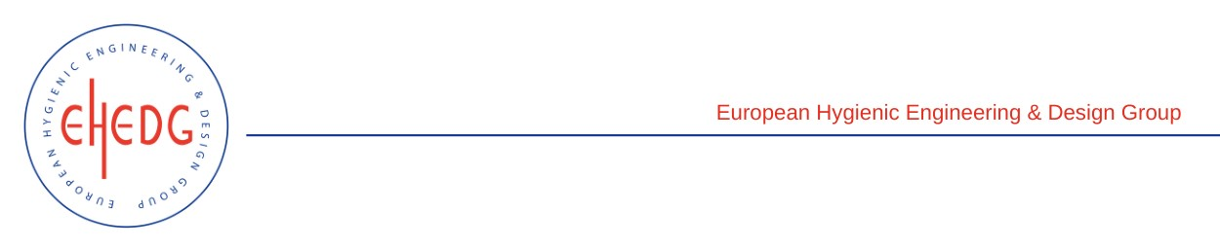

EHEDG Advanced Course on Hygienic Design

24-26 January 2023
Parma (Italy)

Authorised trainer: Giampaolo Betta

Certified Attendees
Accomasso Roberto
Airaldi Camilla
Ancherani Luca
Balbi Davide
Bastoni Andrea
Cavassa Paolo
Cestaro Alessio
Charrier Federico
De Vido Marco
Ducler Andrea
Fenaroli Alessandro
Filip Paolo
Gatti Simone Valentino
Gatti Uberto
Gubbiotti Gabriele
Incantalupo Marco
Mangiarini Anna
Martello Silvia
Meglioli Davide
Molino Clara
Paribello Claudia
Pierantoni Marco Giovanni
Ramponi Piergiorgio
Reggio Fabrizio
Ruaro Carlo
Sarchi Paolo
Tagliaferro Stefano
Viglione Alberto
Viotto Stefano
Vola Stefano

